**VISVESVARAYA TECHNOLOGICAL UNIVERSITY**

**“JnanaSangama”, Belgaum -590014, Karnataka.**



**LAB REPORT**

**on**

**OBJECT ORIENTED PROGRAMMING JAVA**

***Submitted by***

**PRAVIJ GUPTA (1BM21CS141)**

***in partial fulfillment for the award of the degree of***

**BACHELOR OF ENGINEERING**

***in***

**COMPUTER SCIENCE AND ENGINEERING**



**B.M.S. COLLEGE OF ENGINEERING**

**(Autonomous Institution under VTU)**

**BENGALURU-560019**

**Oct 2022-Feb 2023**

**B. M. S. College of Engineering,**

**Bull Temple Road, Bangalore 560019**

(Affiliated To Visvesvaraya Technological University, Belgaum)

**Department of Computer Science and Engineering**



**CERTIFICATE**

This is to certify that the Lab work entitled “**OBJECT ORIENTED PROGRAMMING JAVA**” carried out by **PRAVIJ GUPTA(1BM21CS141),** who is bonafide student of **B. M. S. College of Engineering.** It is in partial fulfillment for the award of **Bachelor of Engineering in Computer Science and Engineering** of the Visvesvaraya Technological University, Belgaum during the year 2022-23. The Lab report has been approved as it satisfies the academic requirements in respect of OBJECT ORIENTED PROGRAMMING JAVA Lab **-** work prescribed for the said degree.

name of the Lab-Incharge               **Dr. Jyothi S Nayak**

Designation Professor and Head

Department of CSE Department of CSE

BMSCE, Bengaluru BMSCE, Bengaluru

`

**Index Sheet**

|  |  |  |
| --- | --- | --- |
| **Sl. No.** | **Experiment Title** | **Page No.** |
| 1 | Quadratic Equation | 4 |
| 2 | Book Details | 5 |
| 3 | Shape | 8 |
| 4 | SGPA Calculator | 9 |
| 5 | Bank | 12 |
| 6 | Wrong Age | 15 |
| 7 | Tester | 17 |
| 8 | Threads | 19 |
| 9 |  |  |
| 10 |  |  |

**Course Outcome**

|  |  |
| --- | --- |
|  |  |
|  |  |
|  |  |
|  |  |

**Lab Program: 1**

**Quadratic Equation**

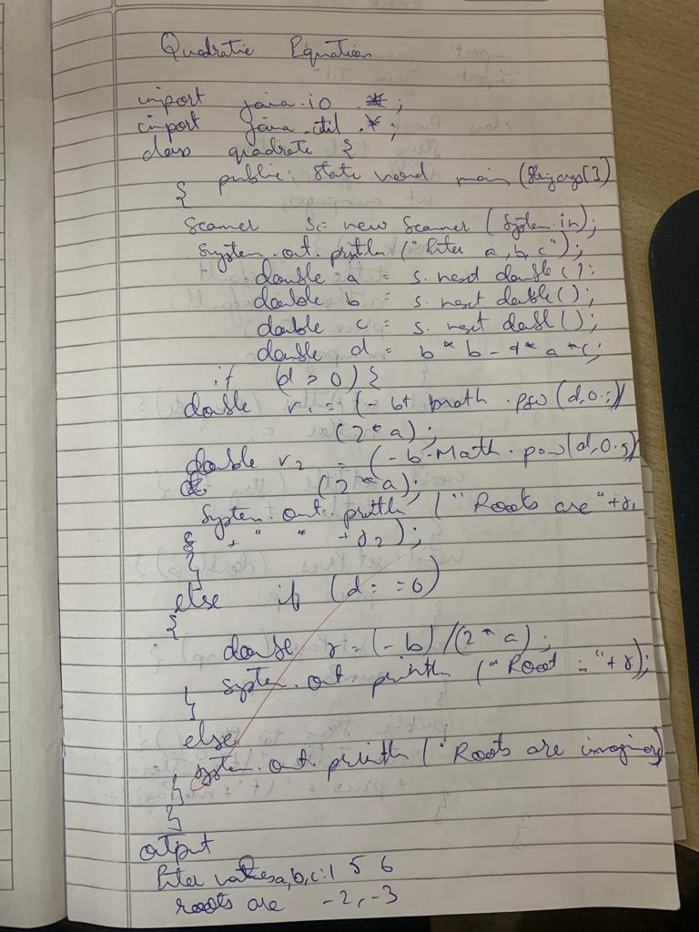

**Output:**

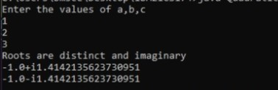

**Lab Program: 2**

**Book Details**

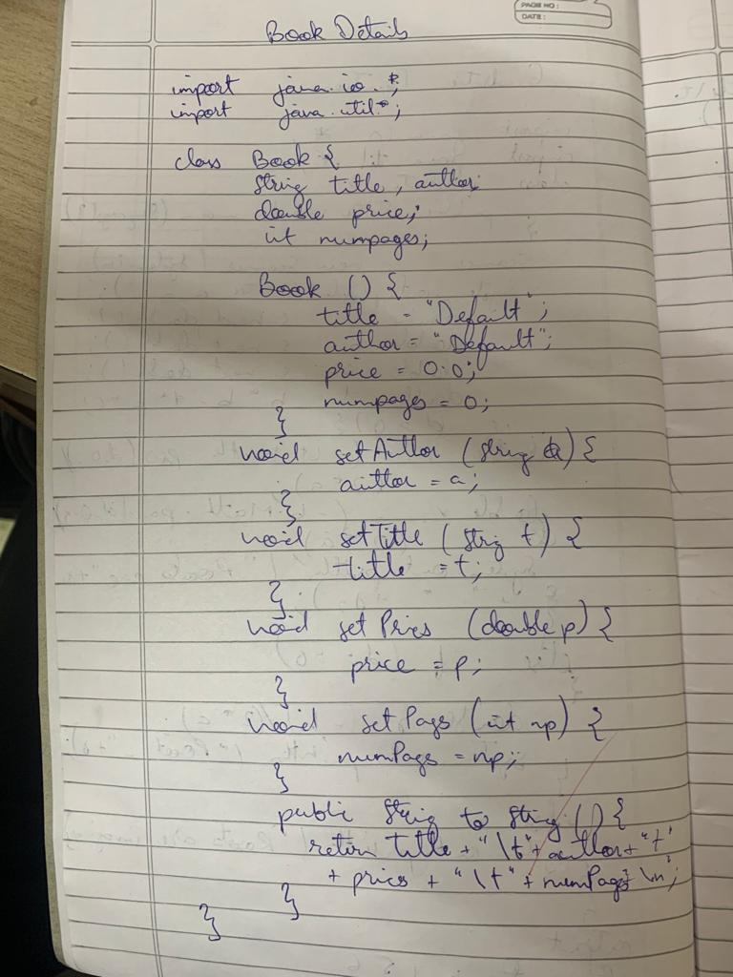

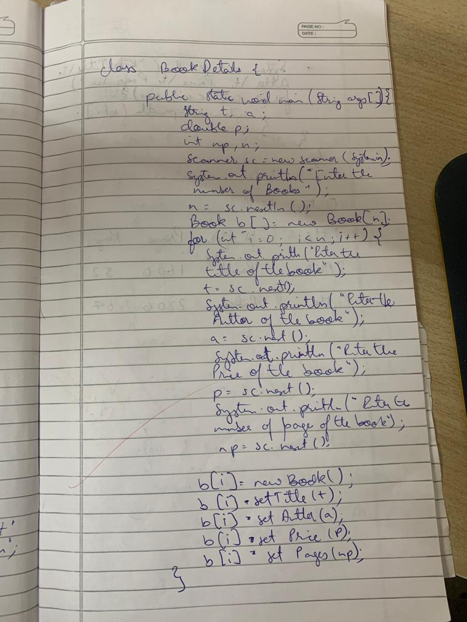

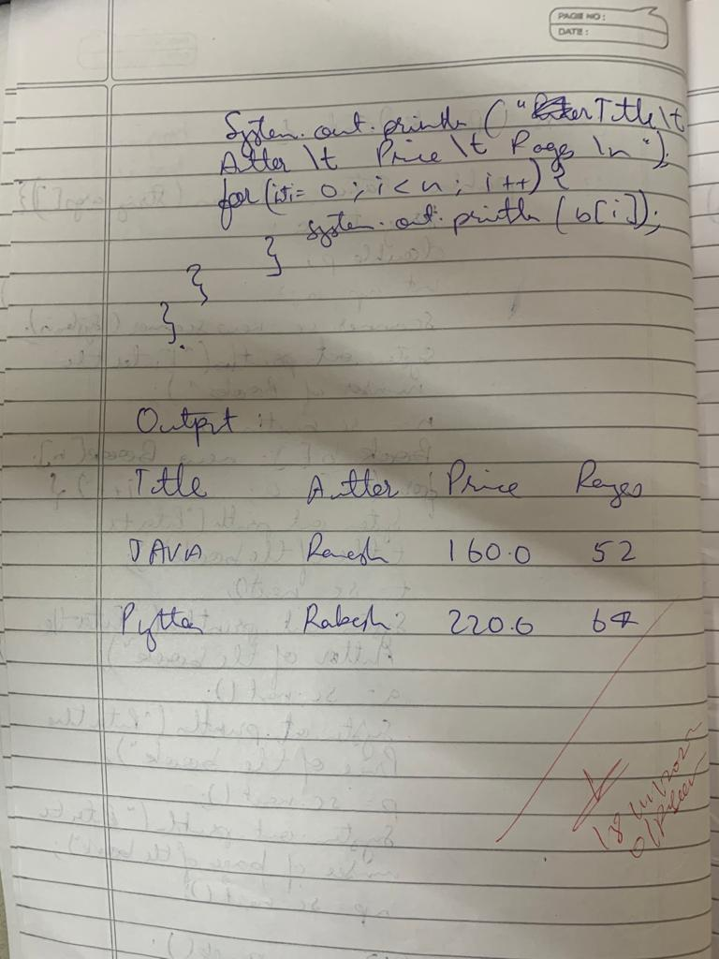

**Output:**

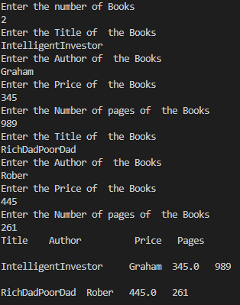

**Lab Program: 3**

**Shape**

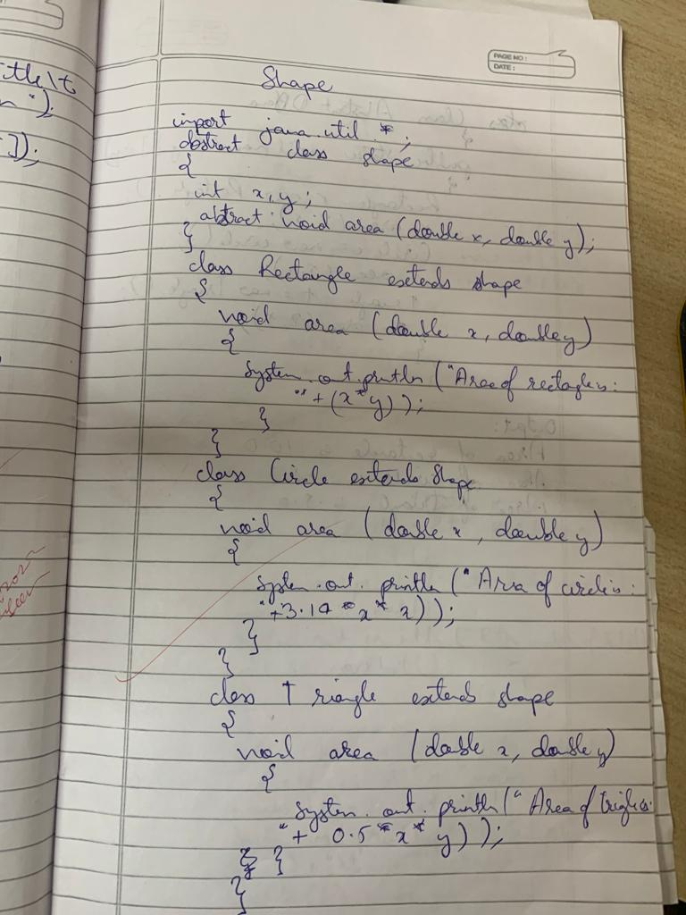 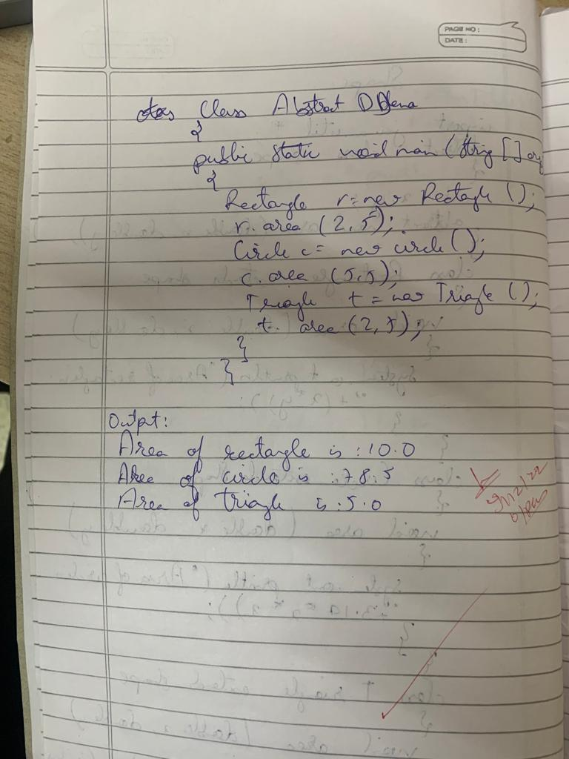

**Output:**

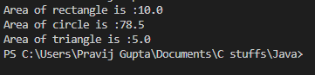

**Lab Program: 4**

**SGPA**

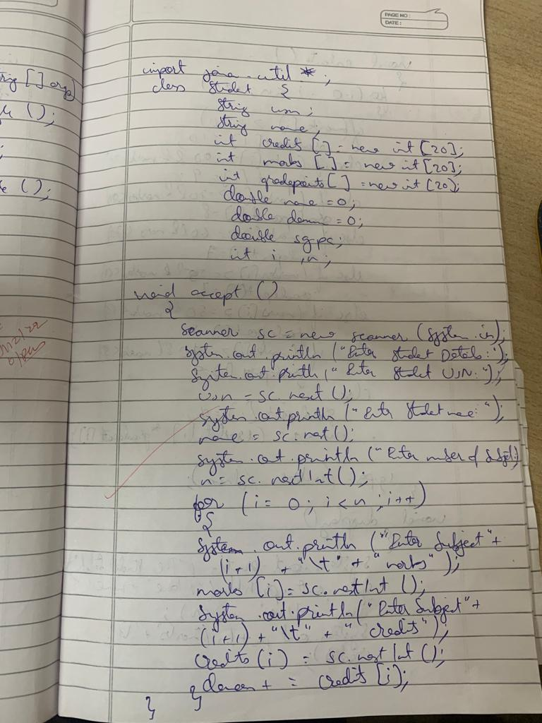

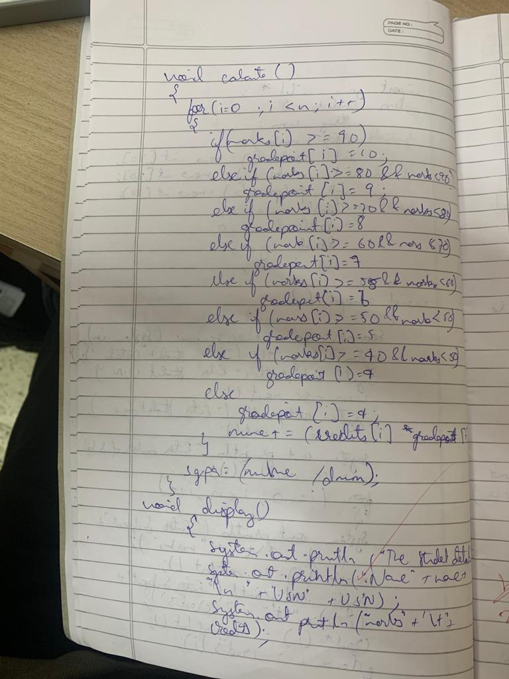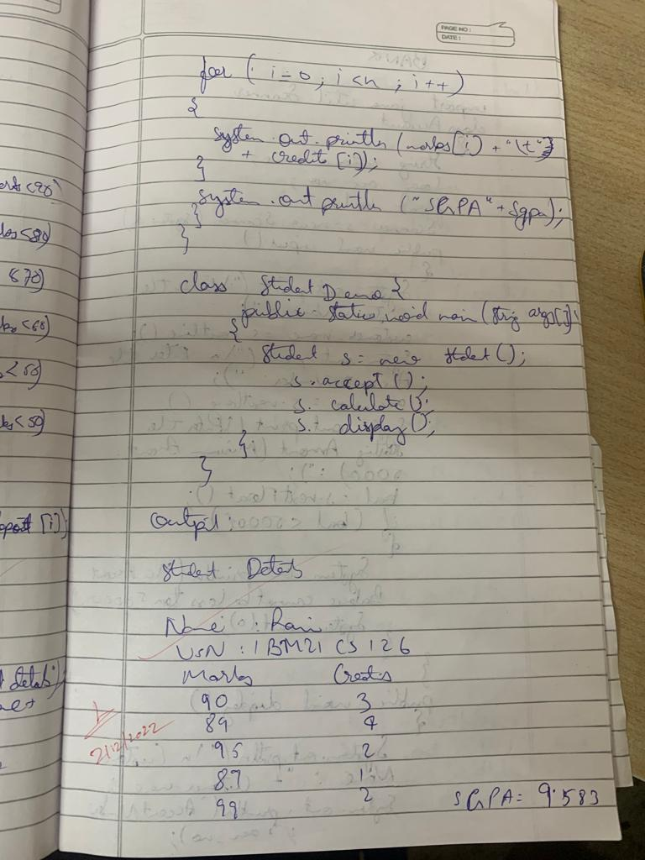

**Output:**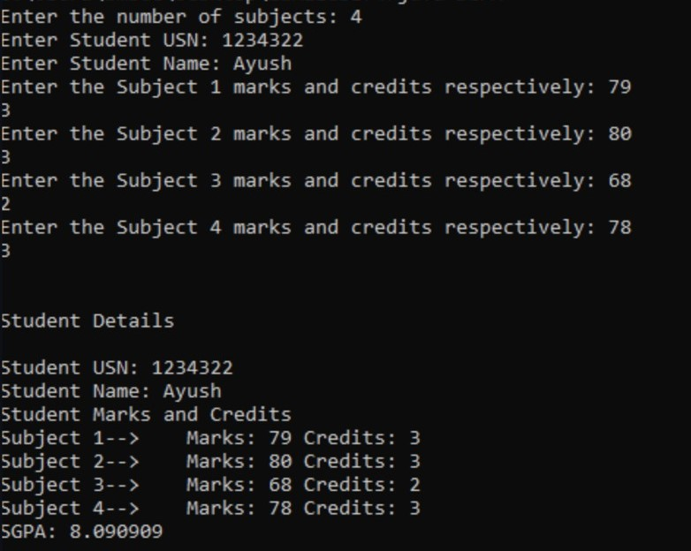

**Lab Program: 5**

**Bank**

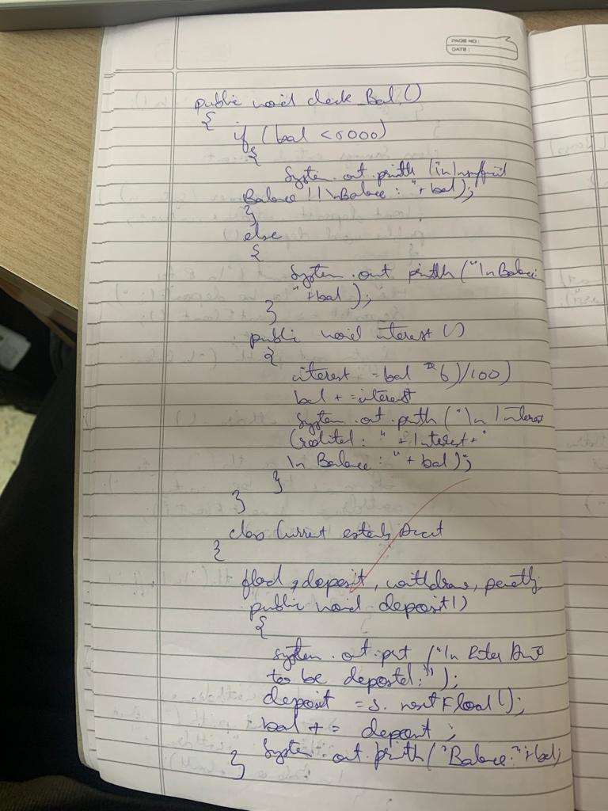 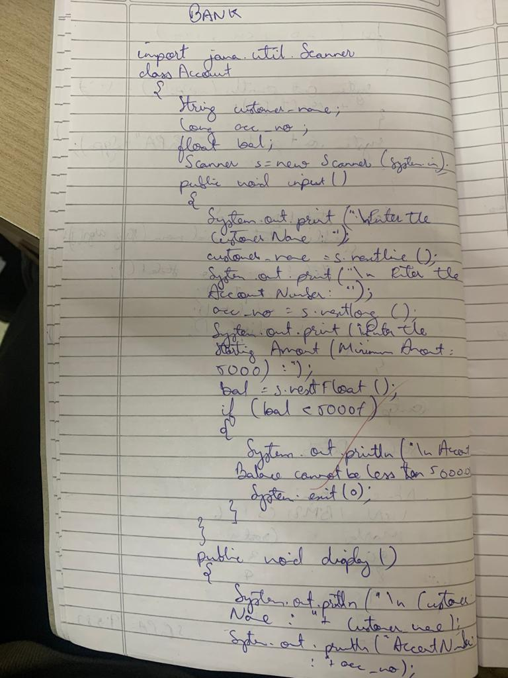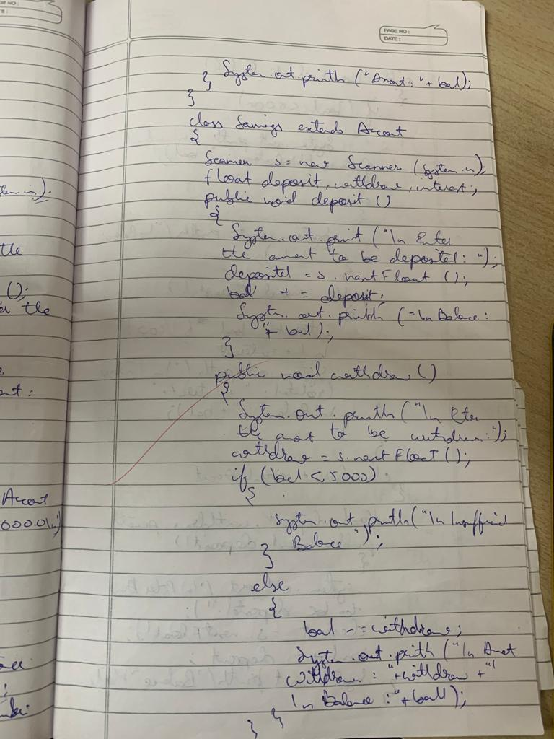 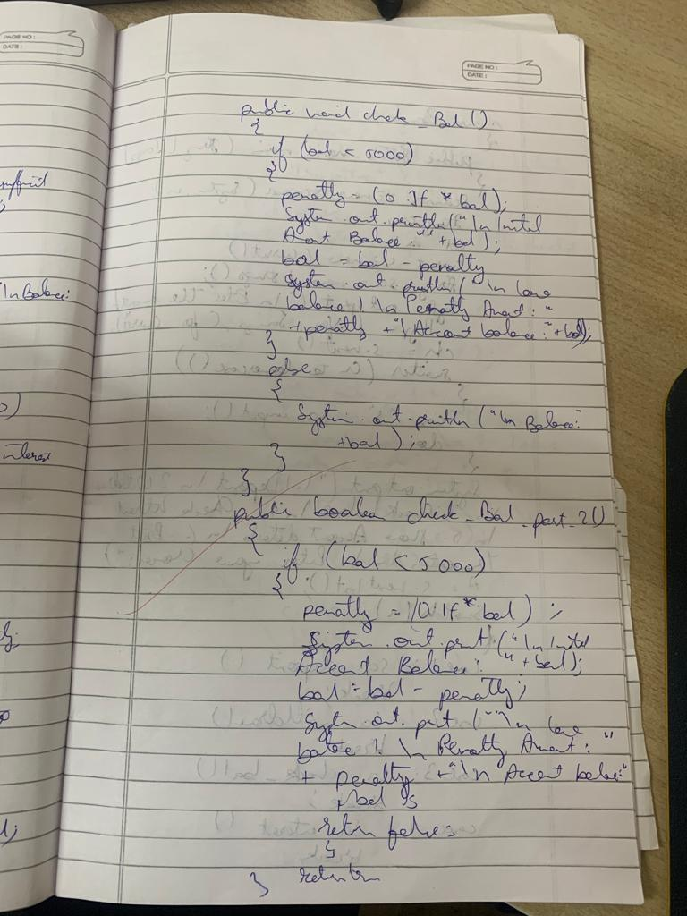

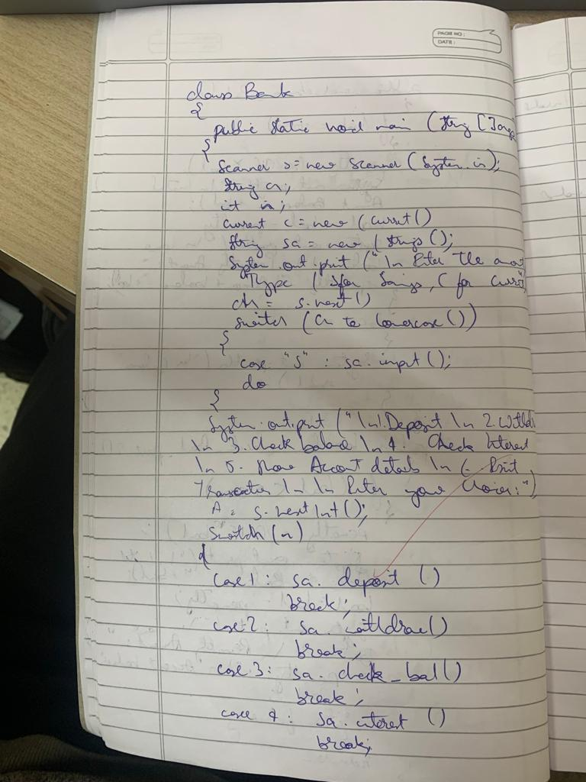 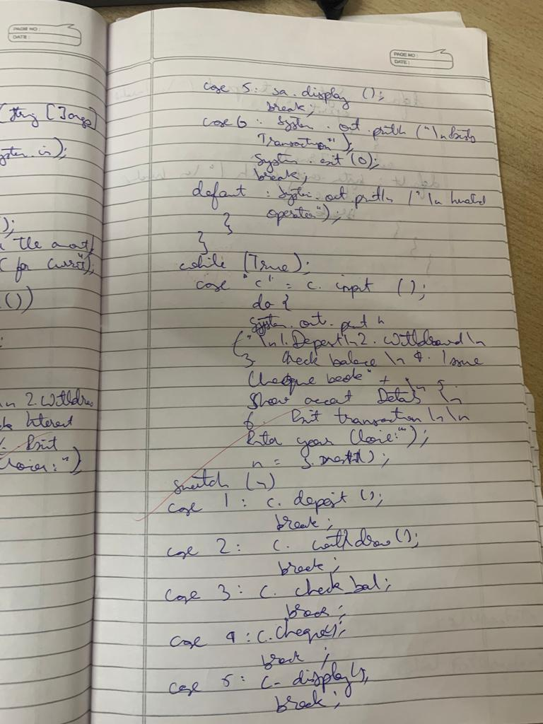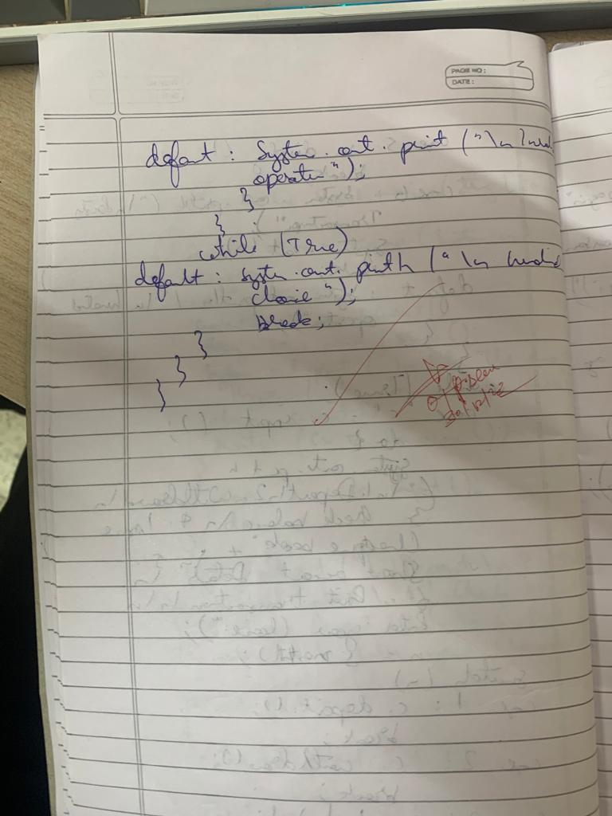

**Output:**

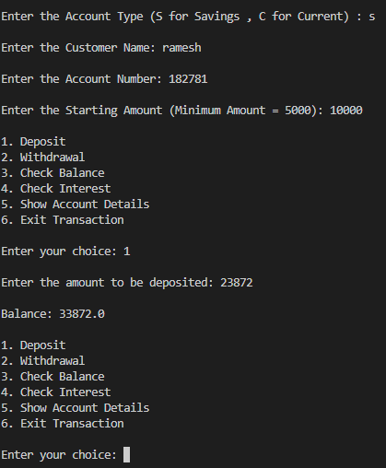

**Lab Program: 6**

**Wrong Age**

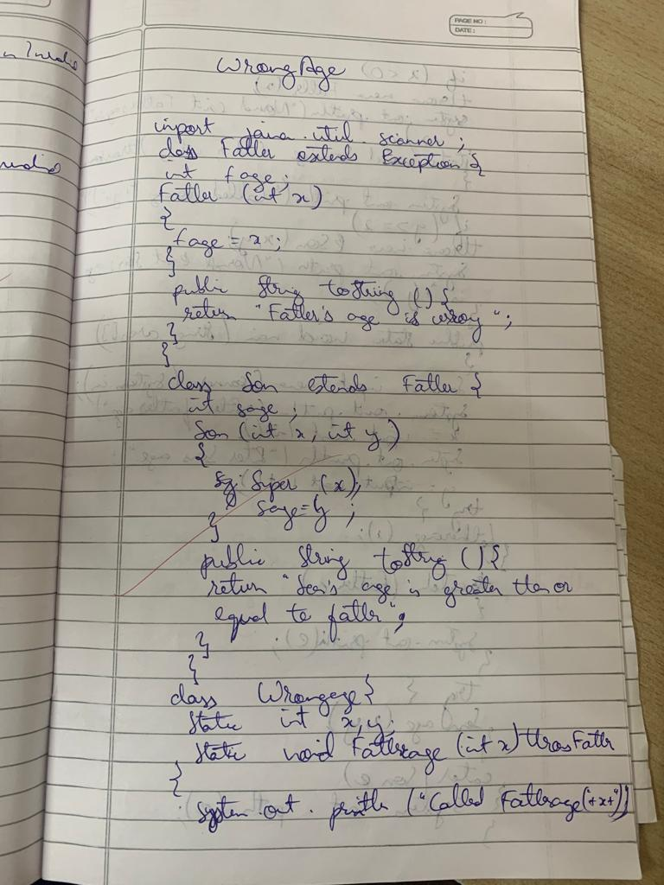 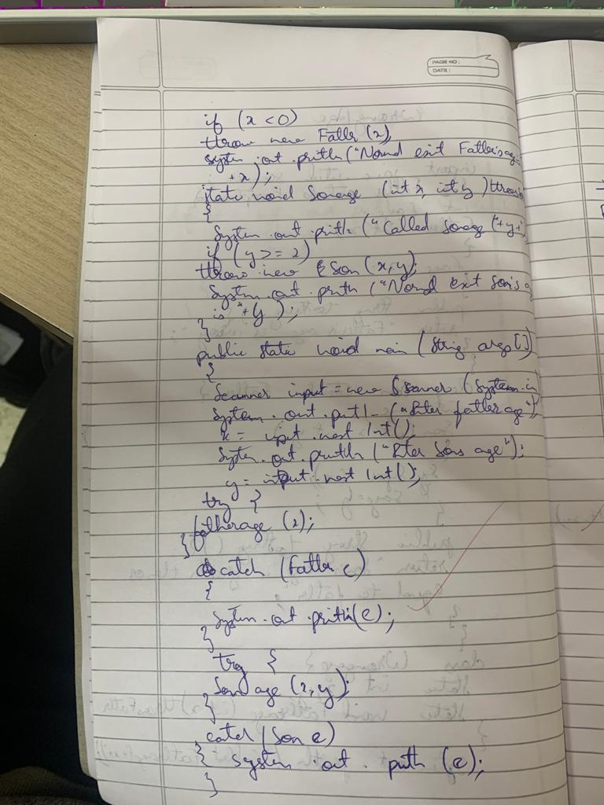

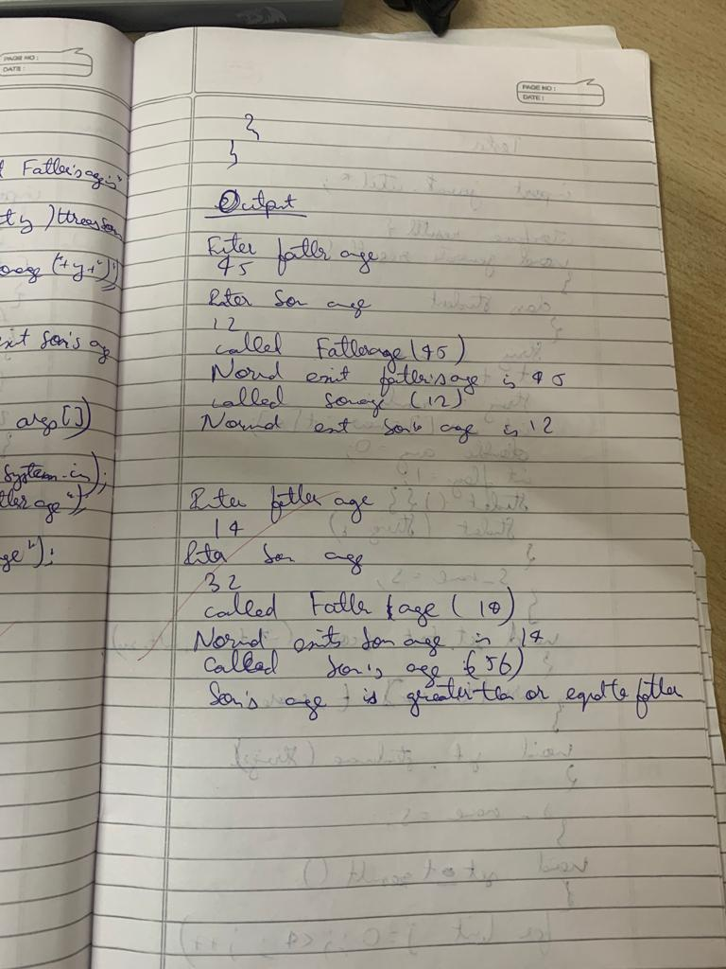

**Output:**

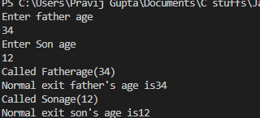

**Lab Program: 7**

**Tester**

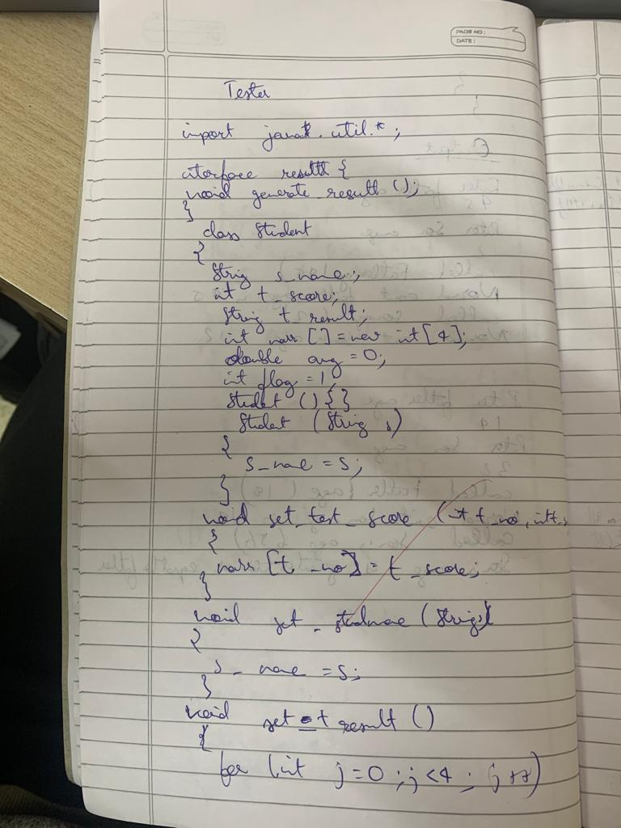 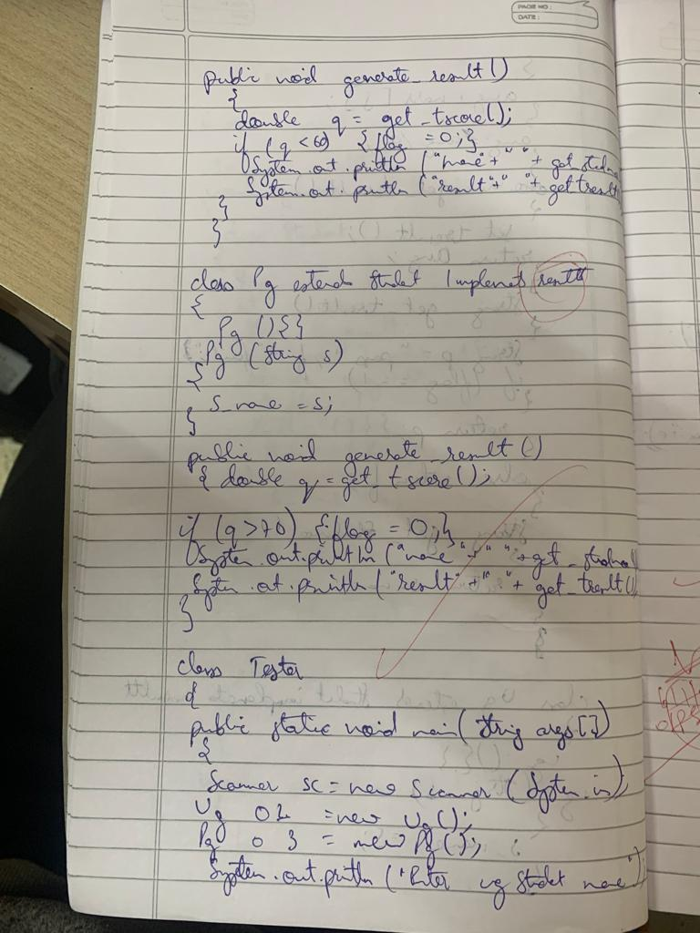

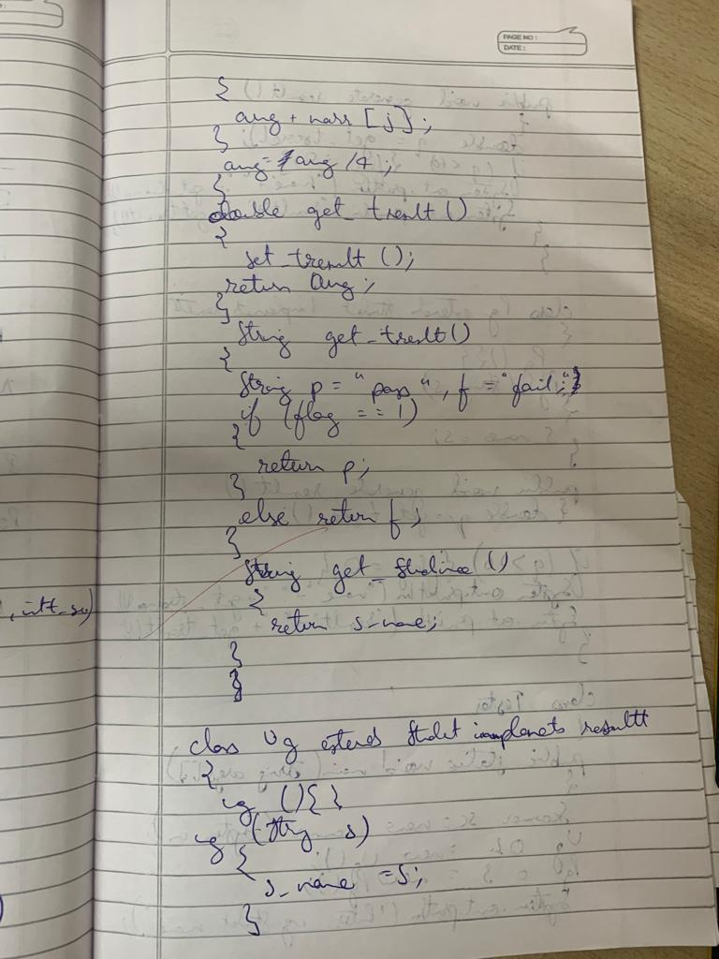 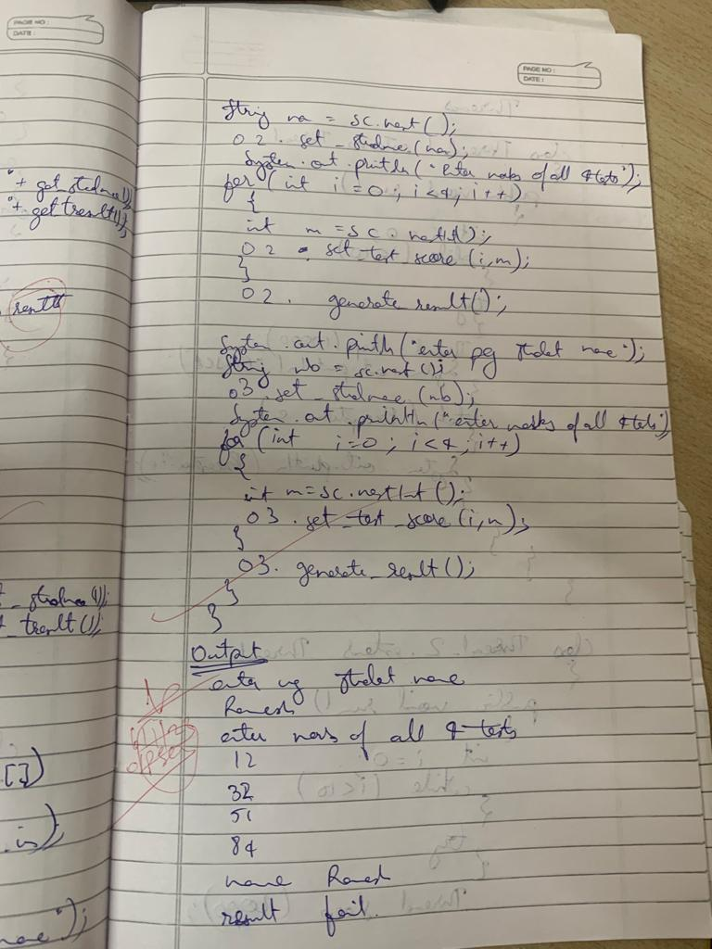

**Output:**

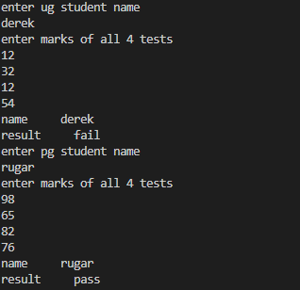

**Lab Program: 8**

**Threads**

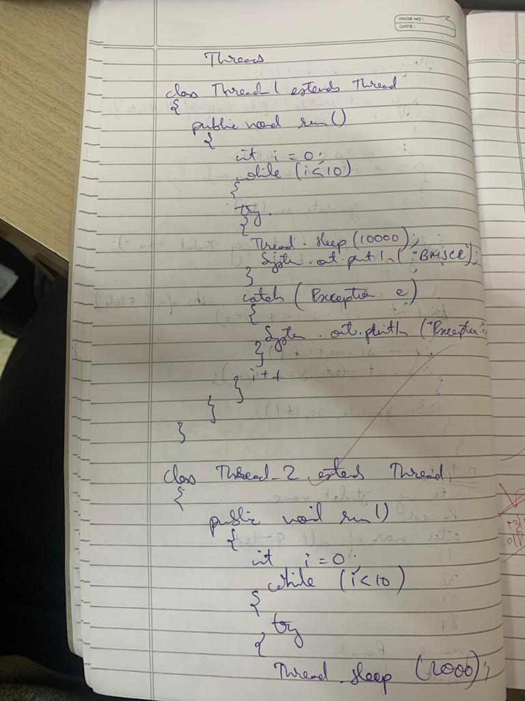

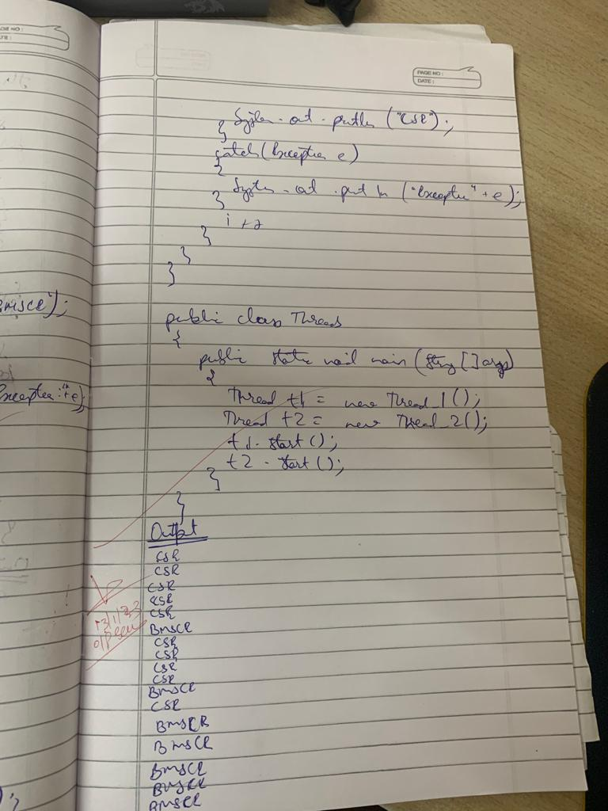

**Output:**

